CSC155

Objective:

The Purpose of this lab is to have the student write a library for reading input from a GPIO PIN. Each student will complete this lab in two steps. Step one will be editing an existing sample program for reading from the GPIO, and the second part will be writing a simple library that will be used to read from a pin, given the physical pin number.

Description (How the program should work) Part I:

Lab prerequisite: Each student should have completed the lab on making an LED blink.

For part 1, the student should wire their breadboard as shown bellow.

Edit the input.c program as to be sure that the correct GPIO pins are used compile and run the input.c program. The input.c program is located in the examples directory on the pi.

 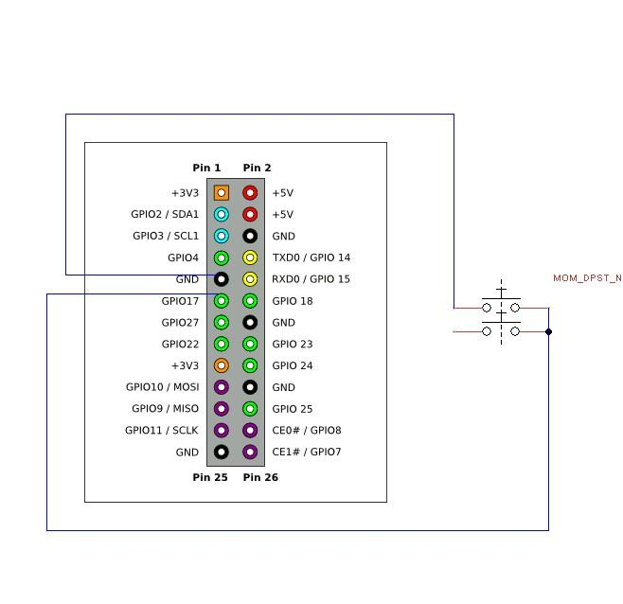

Notice that it indicates the value read from the pin 0 for off and 1 for on.

Edit the input.c program. This time add an if statement that will indicate when the button is pressed and when the button is released using the returned values for the function.

Compile and run the program. Notice the number of times that you output is printed to the screen. Edit your program again to have it print once, when the button is pressed and once when it is released. You may want to use a flag variable for this. A flag variable, is a variable that is used to “flag” an event that may have occurred. In this case, the event that we want to “flag” will be that the button is pressed. This variable will be set to true when the button is pressed and then false when released.

PartII Binary Counter:

This portion of the lab will utilize your library from the Blink program. Keep in mind, that you do not have to use all functions in your previous library for this project. I leave that up to the student. You will, however create a new function for this library that will return the number of times a button is pressed (may not be used, but handy to have).

Functions needed to be created and added to the library:

The student can add to their existing library a read function that initializes the GPIO header and then reads from the GPIO pin.

int readButtonPress(int pin);

The return value of this function will be the total number of times the button is pressed.

The students will now rewire their breadboard as follows

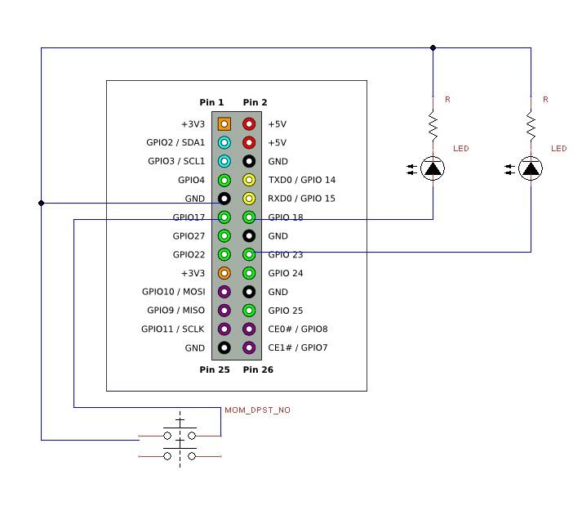

The Idea of this project is that the LED will keep count of the number of presses made with the button. The output will be in Binary. For example 00 01

10 11 . You will use the output of the new function to determine which LED’s will be lit. For example, if the return value of the function is 2, the LED’s will light 10, etc.

You will reuse your functions created in your Blink function, you feel are needed for this project.

You will submit your new library files (including the header), the main function and the makefile.

As always, if you have any questions, please let me know,